Code 1.1.1 } Write a Python program that calculates the area of a circle when the radius is provided by the user. Use π = 3.14 and display the area.
Algorithm :
Step 1 : start the code
Step 2 : taking input of radius
Step 3 : calculating area = pi * radius * radius
Step 4 : end

Code :
Pi = 3.14
Radius = float(input())
Area = Radius * Radius * Pi
Print(f”{Area:.4f}”)

Flow chart :
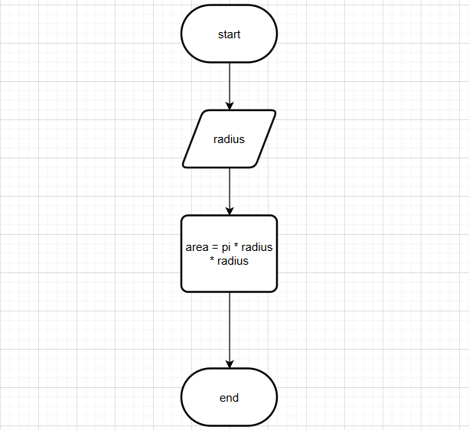

Codetantra :
